Eye Detection Using Morphological and Color Image Processing
Tanmay Rajpathakª, Ratnesh Kumar^{b} and Eric Schwartz^{b}
ª Department of Mechanical Engineering, University of Florida, Gainesville, Florida
^{b} Machine Intelligence Laboratory, Department of Electrical and Computer Engineering, University of Florida, Gainesville, Florida
Abstract
Eye detection is required in many applications like eye-gaze tracking, iris detection, video conferencing, auto-stereoscopic displays, face detection and face recognition. This paper proposes a novel technique for eye detection using color and morphological image processing. It is observed that eye regions in an image are characterized by low illumination, high density edges and high contrast as compared to other parts of the face. The method proposed is based on assumption that a frontal face image (full frontal) is available. Firstly, the skin region is detected using a color based training algorithm and six-sigma technique operated on RGB, HSV and NTSC scales. Further analysis involves morphological processing using boundary region detection and detection of light source reflection by an eye, commonly known as an eye dot. This gives a finite number of eye candidates from which noise is subsequently removed. This technique is found to be highly efficient and accurate for detecting eyes in frontal face images.

1. Introduction
Human face image analysis, detection and recognition have become some of the most important research topics in the field of computer vision and pattern classification. The potential applications involve topics such as face detection, face identification and recognition, and facial expression analysis. Among these research topics, one fundamental but very important problem to be solved is automatic eye detection. The eye is the most significant and important feature in a human face, as extraction of the eyes are often easier as compared to other facial features. Eye detection is also used in person identification by iris matching. Only those image regions that contain possible eye pairs will be fed into a subsequent face verification system. Localization of eyes is also a necessary step for many face classification methods. For comparing two faces, the faces must be aligned. As both the locations of eyes and the inter-ocular distance between them are relatively constant for most people, the eyes are often used for face image normalization.

Eye localization also further facilitates the detection of other facial landmarks. In addition, eyes can be used for crucial face expression analysis for human computer interactions as they often reflects a person’s emotions.

The commonly used approaches for passive eye detection include the template matching method [6, 7], eigenspace [2, 3, 8] method, and Hough transform-based method [1, 4].

In the template matching method, segments of an input image are compared to previously stored images, to evaluate the similarity of the counterpart using correlation values. The problem with simple template matching is that it cannot deal with eye variations in scale, expression, rotation and illumination. Use of multiscale templates was somewhat helpful in solving the previous problem in template matching. A method of using deformable templates is proposed by Yuille et al [9]. This provides the advantage of finding some extra features of an eye like its shape and size at the same time. But the rate of success of this approach depends on initial position of the template. Pentland et al. [8] proposed an eigenspace method for eye and face detection. If the training database is variable with respect to appearance, orientation, and illumination, then this method provides better performance than simple template matching. But the performance of this method is closely related to the training set used and this method also requires normalized sets of training and test images with respect to size and orientation.

Another popular eye detection method is obtained by using the Hough transform. This method is based on the shape feature of an iris and is often used for binary valley or edge maps [10, 11]. The drawback of this approach is that the performance depends on threshold values used for binary conversion of the valleys.

Apart from these three classical approaches, recently many other image-based eye detection techniques have been reported. Feng and Yuen [12] used intensity, the direction of the line joining the centers of the eyes, the response of convolving an eye variance filter with the face image, and the variance projection function (VPF) [13] technique to detect eyes. Zhou and Geng [14] extended the idea of VPF to the generalized projection function (GPF) and showed with experimental results that the hybrid projection function (HPF), a special case of GPF, is better than VPF and integral projection function (IPF) for eye detection. Kawaguchi and Rizon [10] located the iris using intensity and edge information. They used a feature template, a separability filter, the Hough transform, and template matching in their algorithm. Sirohey and Rosenfeld [24] proposed an eye detection algorithm based on linear and nonlinear filters. Huang and Wechsler’s method [16], used genetic algorithms and built decision trees to detect eyes. For the purpose of face detection, Wu and Zhou [17] employed size and intensity information to find eye-analog segments from a gray scale image, and exploited the special geometrical relationship to filter out the possible eye-analog pairs. Han et al. [18] applied such techniques as morphological closing, conditional dilation and a labeling process to detect eye-analog segments. Hsu et al. [19] used color information for eye detection.

Although much effort has been spent and some progress has been made, the problem of automatic eye detection is still far from being fully solved owing to its complexity. Factors including facial expression, face rotation in plane and depth, occlusion and lighting conditions, all undoubtedly affect the performance of eye detection algorithms. The method proposed in this paper involves skin detection to eliminate background components followed by eye detection.

2. Skin Detection
The detection of the skin region is very important in eye detection. The skin region helps determining the approximate eye position and eliminates a large number of false eye candidates. In this paper, we have used a combination of HSV, RGB and NTSC spaces to increase the efficiency of eye detection. The following training techniques were used for detection. First, the code was trained manually on a few images for skin color. The data was obtained for all the color space components, and was fitted to a Gaussian curve. Care must be observed while training, to avoid unwanted pixels like facial hair and creases, as we trained images for only one peak and that peak should be the color of skin. Finally, the six-sigma technique was used for detection. It was observed that HSV space was the most efficient space for skin detection. Figure 2 represents the skin detected region from figure 1.
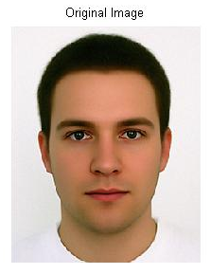
Fig. 1 Original Image
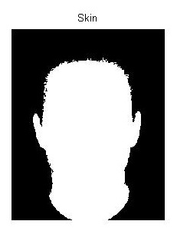
Fig. 2 Skin Detection

3. Eye Detection
The eye detection technique used here is based on the fact that whenever an eye is properly illuminated, it has a sharp point of reflection. This point will be referred to as a light dot. NTSC format is most efficient in exploiting this light dot. Hence, the image is first converted into an NTSC image and the chrominance values of its pixels are used for further processing.

The next step in eye detection involves edge detection. Morphological techniques are used for boundary detection. Dilation, followed by erosion and the calculation of differences between the two produces an image with boundaries. The structuring element used in dilation and erosion has a large matrix (9×9 ones), so that clear and thick boundaries are detected. For the purpose at hand, this technique is found to be more efficient that the Canny edge detector. This is followed by suitable thresholding of the image. The light dot is one of the first few candidates that stand out when the image is thresholded. Selection of a proper thresholding value is important, and a complex process, as this value varies as the image changes. Hence, an adaptive thresholding technique is used. Calculation of this value is achieved by an iteration process. The value is started at 220 on a 255 scale and is decreased by 5 per iteration. The aim of the iteration process is to obtain a minimum number of four and a maximum number of six blobs. It was observed statistically that between these values, thresholding is most probable to output both eyes and with minimum noise. Thresholding is followed by morphological closing, which improves the ease of eye detection and eliminates stray points. Sample outputs of figure 3 are shown in figure 4.

Some of the blobs obtained in the image are too small, and some are too large, and both are unlikely to be candidates for an eye. Hence, they are morphologically eliminated. This is followed by eliminating long and slender blobs, either horizontal or vertical ones, as these blobs are certainly not eyes. Again, morphological binary image processing is used. This image and skin image are combined by using an ‘And’ operation. Only the common candidates survive, as eyes invariably lie in the face region. This whole process is included in a loop and the number of emerging candidates is checked at the end of the loop. If this number is not between 4 and 6, the threshold value is changed, for the next loop.

Fig. 3 Original Image


Fig. 4 Sample Result

Now, the job at hand is to eliminate the noise and obtain the two blobs which represent the eye region. The logic used here is that in a frontal face photograph, eyes lie more or less in the same horizontal line. Hence, a condition is imposed that for a blob A, if there is no blob B, such that maximum y value of A is greater than minimum y value of B, and maximum y value of B is greater than minimum y value of A, then A is not a candidate for eye. Another condition imposed is on the lower limit and upper limit of the distance between A and B. This eliminates a considerable number of noise points. The main problem now is the condition where there are 3 points in a line. Many times, it is observed that 2 of the three points are very close to each other, and both are actually part of the same eye. This problem is tackled by horizontal dilation, which connects the two points and leaves us with two candidates, which are eyes. Figure 6 shows noise eliminated image from figure 5. Figure 7 and 8 are the sample result images.

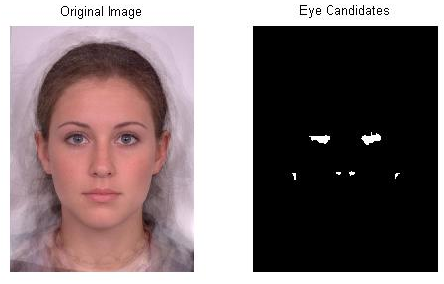
Fig. 5 Eye candidates


Fig. 6 Detected eye regions

Sample Results

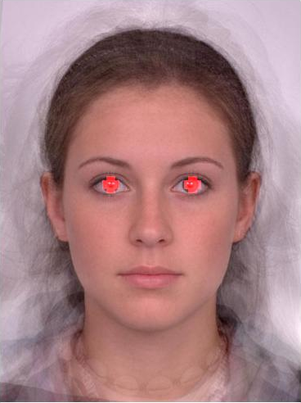
Fig. 7 Sample Result 1

Fig. 8 Sample Result 2

Conclusion and Future Work

In this paper a simple and efficient eye detection method for detecting faces in color images is proposed. It is based on a robust skin region detector which provides face candidates. This is followed by morphological processing and noise elimination which produces eye candidates. The final two candidates are selected by applying rules that define the structure of a human face. It is observed from the results that this technique is successful for 90% of frontal face images, which show two clearly illuminated eyes. However, this technique does not work for most profile images. The method also fails when one or both eyes are closed. The current code is written in MATLAB and requires 15-20 seconds of run-time on a 2GHz processor. However, it is expected that C-based code will take less than 1 second. Future work includes converting this code into the C language and to use a webcam. The webcam eye detection can be very useful and user friendly, as user can give inputs to the computer using eye movement. For example, cursor movement using gaze detection and tracking can eliminate the need for a computer mouse and can convey simplicity and user-friendliness in the operating system.

Further improvement also includes detection of eyes in multiple faces, and faces with different orientations.

References:
- A Robust Eye Detection Method Using Combined Binary Edge and Intensity Information. Jiatao Song, Zheru Chi, Jilin Liu. Science Direct, Pattern Recognition 39 (2006) 1110-1125.
- A Simple and Efficient Eye Detection Method in Color Images. D.Sidibe, P.Montesinos, S.Janaqi. Parc Scientifique G.Besse, France.
- A Hybrid Method for Eye Detection in Facial Images. Muhammed Shafi, Paul W.H.Chung. Waset. www.waset.org.
- Digital Image Processing. R.C. Gonzalez and R.E.Woods, 2nd edition PHI, Chapter 9, Morphological Image Processing.
- Handbook of Image and Video Processing. (AL Bovik) Section III, Chapter 3.3, Morphological Filtering for Image Enhancement and Detection.
- R.Brunelli, T.Poggio, Face Recognition, Features versus templates, IEEE Trans. Patt. Anal. Mach. Intell. 15(10)(1993) 1042-1052.
- D.J.Beymer, Face Recognition under varying pose, IEEE Proceedings of Int. Conference on Computer Vision and Pattern Recognition (CVPR’94), Seattle, Washington, USA,1994, pp.756-761.
- A.Pentland, B.Mognanddam, T.Starner, View based and modular eigenspaces for face recognition in , IEEE Proceedings of Int. Conference on Computer Vision and Pattern Recognition (CVPR’94), Seattle, Washington, USA,1994, pp.756-761.
- A.L.Yuille, P.W.Hallinan, D.S.Cohen, Feature Extraction From Faces Using Deformable Template, Int. J.Comput.Vision 8(2)(1992) 99-111.
- K.M.Lam, H.Yan, Locating and extracting eye in human face images, Pattern Recognition, 29(5)(1996) 771-779.
- G.Chow, X.Li, Towards a system of automatic facial feature detection, Pattern Recognition (26)(1993) 1739-1755.
- G.C.Fang, P.C.Yuen, Multi cues eye detection on gray intensity image, Pattern Recognition (34)(2001) 1033-1046.
- G.C.Fang, P.C.Yuen, Variance Projection function and its application to detection for human face recognition, Pattern Recognition Lett. 19(1998) 899-906.
- Z.H.Zhou, X.Geng, Projection functions for eye detection, Pattern Recognition (37)(5)(2004) 1049-1056.
- S.A.Sirohey, A.Rosenfield, Eye detection in a face image using linear and non linear filters, Pattern Recognition (34)(2001)(1367-1391).
- J.Huang , H.Wechsler, Visual routines for eye localization using learning and evolution. IEEE Trans.Evol.Comput.(4)(1)(2000) 73-82.
- J.Wu, Z.H.Zhou, Efficient face candidate selector for face detection, Pattern Recognition (36)(2003) 1175-1186.
- CC.Hen, H.Y.M.Liao, G.J.Yu, L.H.Chen, Fast face detection via morphology based pre processing. Pattern Recognition 33(2000)1701-1712.
- R.L.Hsu, M.Abdel Mottaleb, A.K.Jain, Face detection in color images, IEEE Trans. Patt. Anal. Mach. Intell. 24(1)(2002) 34-58.

